
COMSATS UNIVERSITY ISLAMABAD
(ATTOCK CAMPUS)
FARYAL BIBI
SP24-BSE-020
SUBMITTED TO MISS AMBREEN GUL
ASSIGNMENT#4
INFORMATION SECURITY

HERE IS THREE TASK

Task 1: Simple RSA Implementation (Without
Libraries)
Objective: Understand the math behind RSA Tasks:
•
Manually implement key generation using small primes • Write functions for: o
Encrypting a message (using public key) o Decrypting a message (using private key) •
Test it on your name or a short string

CODE:
# -------------------------------------------------------------
# TASK 1: SIMPLE RSA IMPLEMENTATION (WITHOUT LIBRARIES)
# -------------------------------------------------------------

import random
from math import gcd

# Function: Extended Euclidean Algorithm to compute modular inverse
def egcd(a, b):
if a == 0:
return b, 0, 1
g, x1, y1 = egcd(b % a, a)
x = y1 - (b // a) * x1
y = x1
return g, x, y

# Function: Modular inverse of e mod phi
def mod_inverse(e, phi):
g, x, y = egcd(e, phi)
if g != 1:
return None
return x % phi

# Function: Check if n is prime
def is_prime(n):
if n < 2:
return False
for i in range(2, int(n**0.5) + 1):
if n % i == 0:
return False
return True

# Function: Generate small random prime
def random_prime():
while True:
x = random.randint(1000, 5000)
if is_prime(x):
return x

# Manual RSA Encrypt
def rsa_encrypt(m, e, n):
return pow(m, e, n)

# Manual RSA Decrypt
def rsa_decrypt(c, d, n):
return pow(c, d, n)

print("\n----- Task 1: Simple RSA (Manual Implementation) -----")

# Step 1: Generate two prime numbers
p = random_prime()
q = random_prime()
while q == p:
q = random_prime()

# Step 2: Compute n and phi(n)
n = p * q
phi = (p - 1) * (q - 1)

# Step 3: Choose public exponent e
e = 65537
if gcd(e, phi) != 1:
e = 17 # fallback

# Step 4: Compute private key d
d = mod_inverse(e, phi)

print(f"Primes: p={p}, q={q}")
print(f"Public Key (e, n) = ({e}, {n})")
print(f"Private Key (d, n) = ({d}, {n})")

# Message to encrypt
message = "Faryal"
print("Original Message:", message)

# Convert to integers
msg_int = [ord(ch) for ch in message]
print("Message (int list):", msg_int)

# Encrypt
encrypted = [rsa_encrypt(m, e, n) for m in msg_int]
print("Encrypted:", encrypted)

# Decrypt
decrypted = [rsa_decrypt(c, d, n) for c in encrypted]
print("Decrypted:", decrypted)

# Convert back to text
decoded = ''.join(chr(x) for x in decrypted)
print("Recovered Message:", decoded)

OUTPUT:
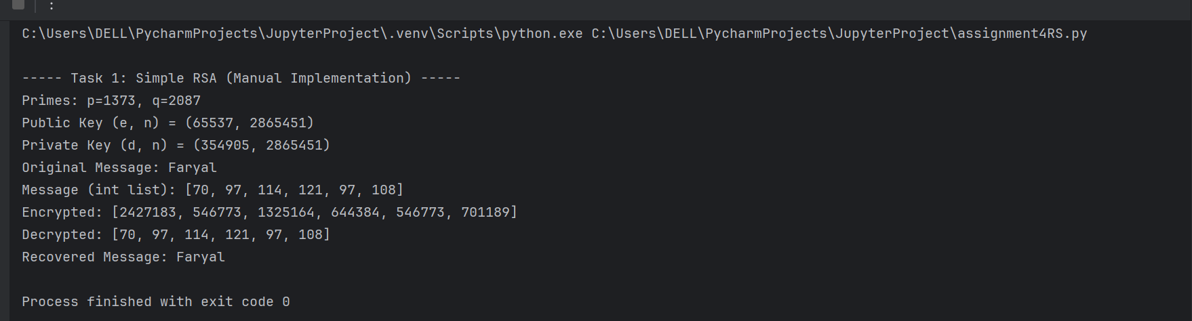

Task 2
CODE:

# -------------------------------------------------------------
# TASK 2: RSA USING PYCRYPTODOME (2048-bit)
# -------------------------------------------------------------

from Crypto.PublicKey import RSA
from Crypto.Cipher import PKCS1_OAEP

print("\n----- Task 2: RSA Using PyCryptodome -----")

# Step 1: Generate secure keys (2048-bit)
key = RSA.generate(2048)
public_key = key.publickey()

# Step 2: Set up cipher for encryption
cipher_encrypt = PKCS1_OAEP.new(public_key)

# 🔥 Updated interesting message
message = "Encryption is like magic—only those with the right key can unlock the secret!"
print("Original Message:", message)

# Step 3: Encrypt (bytes)
ciphertext = cipher_encrypt.encrypt(message.encode())
print("Cipher Text (hex):", ciphertext.hex())

# Step 4: Decrypt
cipher_decrypt = PKCS1_OAEP.new(key)
plaintext = cipher_decrypt.decrypt(ciphertext)

print("Decrypted Message:", plaintext.decode())

Ouput:

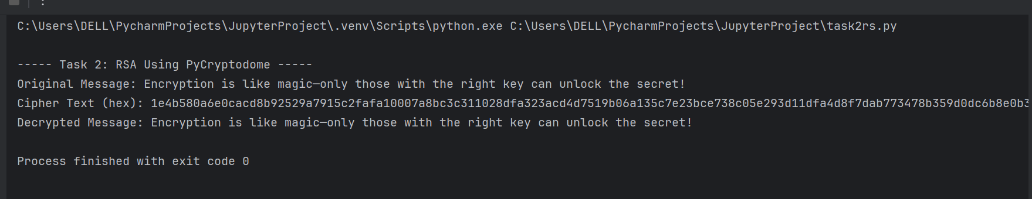
Task 3
Code:
# -------------------------------------------------------------
# TASK 3: DIGITAL SIGNATURE (SHA256 + RSA)
# -------------------------------------------------------------

from Crypto.PublicKey import RSA
from Crypto.Hash import SHA256
from Crypto.Signature import pkcs1_15

print("\n----- Task 3: Digital Signature -----")

# Step 1: Generate keypair
private_key = RSA.generate(2048)
public_key = private_key.publickey()

# Message to sign
message = "This message will be digitally signed."
print("Message:", message)

# Step 2: Create hash
hash_obj = SHA256.new(message.encode())

# Step 3: Sign the hash
signature = pkcs1_15.new(private_key).sign(hash_obj)

print("Signature (hex):", signature.hex())

# Step 4: Verify signature
try:
pkcs1_15.new(public_key).verify(hash_obj, signature)
print("Verification: VALID ✔")
except:
print("Verification: FAILED ✘")

# Step 5: Tampered message
tampered_msg = "This message has been changed!"
tampered_hash = SHA256.new(tampered_msg.encode())

print("\nTesting with Tampered Message...")

try:
pkcs1_15.new(public_key).verify(tampered_hash, signature)
print("Tampered Verification: VALID (Incorrect!)")
except:
print("Tampered Verification: FAILED ✔ (Correct)")

Ouput:
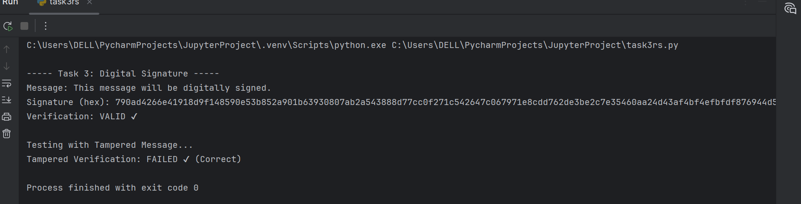

Security Analysis :

1. Manual RSA Security Issues

- Uses very small primes → easily factorable.
- No padding → textbook RSA → insecure.

- Only for learning, NOT real cryptography.

2. PyCryptodome RSA Benefits

- Uses 2048-bit secure keys.

- Uses OAEP padding, which prevents many attacks.

- Uses secure pseudorandom number generator.

3. Digital Signature Security

- Uses SHA-256 hashing (secure).

- Signature created using RSA private key.

- Verification ensures:

- Integrity (no changes allowed)

- Authenticity (comes from real sender)

4. Why Tampering Fails

- Changing even one character → different hash → signature no longer matches.

Conclusion
- All three tasks demonstrate:

- RSA math (manual)

- RSA practical usage (PyCryptodome)

- Digital signatures and verification

- This assignment covers the fundamentals of data confidentiality, authentication, and integrity.

